Target journal: BMC Bioinformatics, Biostatistics (Oxford Academic), Journal of Translational Medicine
Target audience: preclinical researchers interested in computational pharmacology, translational oncology, high-throughput screening (HTS), pharmaceutical R&D
Draft version: vr4.1 (260120)

Introducing S′, an Operational Framework for Bidirectional Drug Response in High-Throughput Viability Screens: Quantifying Inhibition and Disinhibition

Alternative titles under consideration:
A Systems Pharmacology Approach to High-Throughput Screening Using a Potency–Efficacy Index (S’) for Drug Responses
Reframing Drug Response as Net Regulatory Balance: An Operational Approach to High-Throughput Viability Screens

Introducing S′, a Potency–Efficacy Index for High-Throughput Drug Response Profiling

Computational Biology Working Group, MoCo Makers and DMV Petri Dish

1 MoCo Makers, Gaithersburg, Maryland 20879, USA
2 DMV Petri Dish, Rockville, Maryland, USA

Correspondence: matt@mocomakers.com

Keywords: operational pharmacology, Black–Leff model, potency–efficacy index (S′), differential sensitivity, inhibition and disinhibition

ABSTRACT (211 words)
High-throughput screening (HTS), including screens for anticancer agents, should measure both growth inhibition and growth stimulation—such as unexpected activation resulting from feedback or compensatory signaling. Conventional metrics such as IC₅₀, EC₅₀, and AUC quantify potency or overall activity but fail to preserve directionality, obscuring whether a compound inhibits or instead relieves suppression. To address this limitation, we extend the Black–Leff operational model by reformulating the transduction term as a net efficacy parameter capable of representing inhibitory, neutral, and disinhibitory responses. This framework reflects the bidirectional behavior of real signaling networks, where inhibition and feedback-driven activation frequently coexist.
Within this operational context, we define the potency–efficacy index S’ , a unitless, sign-preserving measure that integrates potency, efficacy, and directionality. S′ compresses extreme values while retaining the polarity of drug action, enabling coherent comparison across compounds with descending or ascending dose–response curves. The cohort-level extension, ΔS’ quantifies genotype-specific differences and reveals mutation-dependent vulnerabilities, including suspect synthetic-lethal interactions in PTEN-, TP53-, and NF1-altered backgrounds.
By capturing both inhibition and disinhibition, S′ and ΔS′ provide a unified operational framework for ranking compounds, identifying feedback-driven polarity flips, and mapping pathway dependencies across heterogeneous cancer cell populations. This approach offers a more mechanistically grounded basis for therapeutic prioritization than traditional concentration–response metrics.

INTRODUCTION
Small-molecule drugs and their biological targets are fundamentally tied to how they shift the net balance of inhibitory and disinhibitory signals within the complex, interconnected signaling networks of cells [1]. Rather than simply acting on a target protein in isolation, these drugs often disrupt the equilibrium between, for example, excitatory and inhibitory neural pathways or, in cancer, the balance of protein kinases that regulate cell growth. Disrupting the net balance of complex, interconnected signaling networks has deep implications for cellular diversity, population‑level behavior, and why different cells respond so differently to the same drug [2-4]. This is particularly pertinent for diseases which are often a consequence of multiple changes in the same signaling pathway or related pathway [5-7]. Drug action redistributes signaling flux across a cell population, and in the case of cancer a genetically heterogeneous cell population [8,9]. The shift in balance—between inhibitory forces and disinhibitory forces—can play out differently in every cell and every treated cell population. In this way, the net balance of inhibitory and disinhibitory signaling becomes a central determinant of how cellular phenotypes including viability are expressed, maintained, or reshaped in response to small‑molecule perturbation.
In high-throughput screening (HTS) assays the outcome of pathway perturbation is frequently measured as cell viability [10,11]. These assays typically involve large chemical libraries screened against large cell line libraries. Inhibition is manifested as cytotoxicity, apoptosis, or cytostasis while disinhibition reflects increased growth or survival increases. For anticancer drug panels there has been a natural focus on drug-induced growth inhibition. However, drug-induced direct stimulation of growth or context-dependent growth stimulation can arise from, for example, receptor agonists and antagonists some of which maybe found in chemical libraries. Some GPCR-directed agents can either inhibit or stimulate proliferation depending on cell type or tissue environment [12]. Similarly, androgen- and estrogen receptors, along with their respective agonists and antagonists, can exert complex, context-dependent effects on cell growth, acting as either promoters or inhibitors of proliferation [13-15]. Beyond that many small‑molecule drugs (including some found in chemical libraries) exhibit strong context dependence [16] which can influence the direction of growth control.
In cancer cells, disinhibition can also arise from innate resistance or processes related to acquired resistance such as pathway rewiring, compensatory feedback activation, epigenetic shifts, or altered protein expression, all of which reshape how cells respond to perturbation [3,17-19]. Further blurring growth boundaries, tumor cells evade can inhibition by dampening apoptosis, upregulating survival factors, mutating tumor suppressors, or engaging alternative pathways such as PI3K/AKT [20-22].
Because HTS libraries can contain compounds capable of producing both suppression and disinhibition, restricting analysis to inhibitory responses alone can obscure the true diversity of drug action. Traditional metrics such as IC₅₀, EC₅₀, and AUC emphasize inhibition and fail to capture stimulatory or relief-of-suppression effects. A comprehensive interpretation of concentration–response relationships therefore requires frameworks that explicitly measure the net functional effect including both inhibition and disinhibition as fundamental, biologically meaningful outcomes.
A framework capable of capturing these bidirectional responses (inhibition and disinhibition) requires moving beyond potency only metrics. To this end, we adapt the Black–Leff operational model [23], which classically describes agonist action through receptor affinity (K_{A}) and a strictly positive transduction efficacy (τ). The classical transduction ratio (τ) is replaced with a net transduction efficacy ($τ_{\text{net}}$), which represents the combined influence of inhibitory and disinhibitory processes on pathway output:

$$E=\frac{E_{\text{max}}⋅τ_{\text{net}}⋅\left[A\right]}{K_{A}+\left[A\right]+τ_{\text{net}}⋅\left[A\right]}$$
Here, (E) is the observed effect, ($E_{\text{max}}$) the maximal system response, $\left[A\right]$ the drug concentration, and $K_{A}$ the affinity constant. This extension parallels principles of allostery [24,25] and functional coupling in signaling networks [26,27] enabling the model to represent both suppression and relief-of-suppression—two dynamics that frequently coexist in HTS datasets.
Within this operational framework, we define a nonlinear potency–efficacy index:
$$S^{'}=asinh\left(\frac{E_{\text{max}}}{EC_{50}} x 1 μM\right)$$
The inverse hyperbolic sine transformation (asinh) [28,29] compresses extreme values while preserving sign and rank ordering. Positive S′ values correspond to inhibition whereas negative S′ values reflect disinhibition. The potency–efficacy index S′ can thus be regarded as an operational efficiency index, with ($E_{max}/{EC}_{50})$ as its natural backbone. Unlike IC₅₀, EC₅₀, or AUC, S′ conveys not only the magnitude of drug effect but also its direction. Because S′ and its cohort‑level derivative ΔS′ are bidirectional, they offer clearer insight into whether a compound suppresses or relieves growth, allowing for a fuller understanding of drug effects. This may be particularly relevant in anticancer drug discovery because it provides a more complete representation of the drug's functional action, particularly in the face of innate resistance, oncogenic mutations, loss of tumor suppressors, relief of inhibitory checkpoints, engagement of feedback loops or activation of compensatory pathways all of which can contribute to drug resistance . [22,30,31].

OPERATIONAL MODELING FRAMEWORK
The original Black–Leff model [23] describes agonist action through receptor affinity (K_{A}) and a strictly positive transduction efficacy (τ). To extend this framework to viability assays where compounds can produce both inhibition and disinhibition, we retain the model’s structure but reinterpret τ as a net transduction efficacy (τ_{net}). Rather than representing a single positive efficacy, τ_{net} reflects the combined balance of inhibitory and disinhibitory influences within the signaling network. This preserves the Black–Leff form while letting the 4-parameter logistic (4PL) asymptotes ($E_{max} = A - D)$determine whether the net effect is inhibitory or disinhibitory.

Modeling Drug Action as Net Regulatory Balance
Cell growth and signaling outputs are often governed by a balance of stimulatory and suppressive influences, which can be represented through an effective rate constant describing the net direction and magnitude of pathway activity. Drug responses can be framed similarly: a compound may exert direct inhibitory pressure on a pathway node while simultaneously relieving upstream suppression or triggering compensatory activation. These opposing forces can be represented by two conceptual rate components:
- ($k_{\text{inhib}}>0$): direct inhibitory influence (e.g., target engagement, cytostasis, cytotoxicity)
- ($k_{\text{disinhib}}>0$): disinhibitory influence (e.g., feedback relief, inhibition of a suppressor, paradoxical activation)
The net regulatory effect is then captured by the ratio:
$$k_{\text{net}}=\frac{k_{\text{disinhib}}}{k_{\text{inhib}}}$$
Values ($k_{\text{net}}<1$) reflect dominant inhibition, whereas ($k_{\text{net}}>1$) reflect dominant disinhibition or paradoxical activation.

Extending the Black–Leff Operational Model
The Black–Leff operational model [23] describes the functional response (E) to a ligand concentration (A):
$$E=\frac{E_{\text{max}}⋅τ_{\text{net}}⋅\left[A\right]}{K_{A}+\left[A\right]+τ_{\text{net}}⋅\left[A\right]}$$
where:
- ($E_{max}$): maximal system response
- ($K_{A}$): affinity constant
- ($τ$): transduction ratio linking receptor occupancy to system-level output
To incorporate both inhibitory and disinhibitory influences, we generalize the transduction ratio into a net transduction efficacy:
- ($τ_{\text{inh}}$): inhibitory transduction efficacy
- ($τ_{\text{disinh}}$): disinhibitory transduction efficacy
These can combine either:
- Multiplicatively (modulatory scaling across checkpoints):
$$τ_{\text{net}}=\frac{τ_{\text{disinh}}}{τ_{\text{inh}}}$$
- Additively (opposing forces on the same axis):
$τ_{\text{net}}=τ_{\text{disinh}}-τ_{\text{inh}}$
Multiplicative interactions are expected to dominate in cancer systems, where signaling networks contain layered feedback, adaptive resistance, and nonlinear pathway coupling.
Substituting ( $τ_{\text{net}}$) into the Black–Leff model yields:
$$E=\frac{E_{\text{max}}⋅τ_{\text{net}}⋅\left[A\right]}{K_{A}+\left[A\right]+τ_{\text{net}}⋅\left[A\right]}$$
This formulation captures the net effect of inhibitory and disinhibitory forces on pathway output (Figure 1).

Reformulation in Terms of EC₅₀
The Emax model provides an intuitive description of sigmoidal dose–response curves:
$$E=E_{0}+\frac{E_{max}C^{n}}{{(EC_{50})}^{n}+C^{n}}$$
Black–Leff theory links the operational EC₅₀ to affinity and transduction efficacy [32]:
$$EC_{50} = \frac{K_{A}}{\left(1+τ_{\text{net}}\right)}$$
Substituting this into the E_{max} form shows that the observed response depends jointly on $E_{max}$, $K_{A}$, and the composite term ($1+τ_{\text{net}}$). Rearranging yields the operational potency–efficacy ratio:
$$\frac{E_{max}}{EC_{50}}=\frac{E_{max}\left(1+τ_{\text{net}}\right)}{K_{A}}$$
This ratio increases when efficacy (via $\left(τ_{\text{net}}\right)$) increases or when potency (via $K_{A}$) improves. Because $E_{max}$ may be positive (disinhibition) or negative (inhibition), the ratio preserves directionality of drug action.

High-Throughput Operationalization Using 4PL Parameters
High-throughput screening (HTS) commonly uses the 4PL model:
- (A): minimum response
- (D): maximum response
- (C): EC₅₀
- (B): Hill slope
To align 4PL outputs with the operational framework, we define: $E_{max}=A-D, EC_{50}=C$ and where $E_{max}$ is expressed relative to solvent control, and EC₅₀ is normalized to a 1 μM reference concentration.
Based on common practices in high‑throughput screening (HTS) and specifically within the Cancer Dependency Map (DepMap) project, HTS viability measurements are routinely normalized to enable consistent comparison across compounds and experimental batches. This normalization typically involves: (a) setting the baseline (upper limit) by assigning the appropriate vehicle control (e.g., DMSO) a value of 1, corresponding to 100% viability, and (b) allowing the maximum response (lower limit) to float. The resulting values represent unitless ratios describing the fraction of viable cells relative to the vehicle control.
To align 4PL model outputs with this operational framework, we define $E_{max}=((A-D) x 100), a$nd EC₅₀ = C, where A and D are the normalized upper and lower asymptotes of the fitted curve and EC₅₀ is normalized to a 1 μM reference concentration . The factor of 100 serves only as a unitless scaling constant, ensuring that E_{max} enters the expression ((E_{max}/EC₅₀) x 1 µM) as a dimensionless quantity. Under this convention, the concentration units in cancel, yielding a dimensionless argument for the asinh transformation. Accordingly as below, S′ is a unitless, direction‑preserving index of net drug action.

S′: A Practical Potency–Efficacy Index
To obtain a single, unitless index that reflects both potency and efficacy, we compute:
$$S^{'}=asinh\left(\frac{E_{max}}{EC_{50}}×1 μ\text{M}\right)$$
EC₅₀ values were expressed in μM, and the factor 1 µM was included in the S′ definition to render the potency–efficacy ratio dimensionless. Multiplying by 1 μM converts EC₅₀ into a dimensionless quantity. The inverse hyperbolic sine transformation is monotonic, sign-preserving, and log-like, compressing extreme values and symmetrically representing effects around zero to prevent outliers from dominating rankings. Positive S′ values indicate net inhibition; negative values indicate net disinhibition. The magnitude of S′ reflects the strength of the effect, with small values behaving linearly and large values compressed logarithmically, enabling direct comparison of inhibitory and disinhibitory responses on a unified scale.
Because $E_{max}/EC_{50}$ reflects the operational potency–efficacy ratio, S′ provides a stable, direction-preserving ranking index that summarizes net drug action across both inhibitory and disinhibitory conditions.
It is noted that as S′ reflects the net functional effect of a compound on the cell, traditional mechanistic labels (e.g. partial or full agonist, allosteric activator or modulator, competitive inhibitor) do not map cleanly onto it. These terms describe molecular mechanisms at a specific target, whereas S′ captures the integrated outcome of all pathway interactions, including feedback, compensatory signaling, and off‑target effects. As a result, S′ is best interpreted as a direction‑preserving measure of the overall cellular response, independent of the compound’s classical pharmacologic classification

Cohort-Level Aggregation: $\overline{S^{'}}$
For a compound tested across (n) cell lines within a defined cohort:
$$\overline{S^{'}}=\frac{1}{n}\sum_{i=1}^{n}{S_{i}^{'}}$$
This provides a pooled estimate of net inhibitory or disinhibitory activity across similar populations.

Differential Sensitivity Metric: ΔS′
To quantify genotype-specific differences in drug response, we computed:
$$ΔS^{'}={\overline{S^{'}}}_{reference}- {\overline{S^{'}}}_{test}$$
Specifically for mutant vs wild type:
$$ΔS^{'}={\overline{S^{'}}}_{wild type}- {\overline{S^{'}}}_{mutant}$$
Interpretation:
- ΔS′ < 0 → reference/mutant cohort more inhibited
- ΔS′ > 0 → reference/mutant cohort more resistant or paradoxically activated
- ΔS′ ≈ 0 → functional equivalence
ΔS′ preserves the directionality of S′ and enables systematic comparison across cohorts.

Application of the Ranking Framework Using S′
The S′ index can be applied to individual cell lines or to collections of lines sharing phenotypic or genotypic features (Figure 1). Histograms of S′ values for the full cohort of CNS cancer cell lines, and separately for the A172 glioma line, reveal a clear bimodal distribution: a large cluster of positive S′ values (growth inhibition) and a substantial cluster of negative S′ values (disinhibition). This pattern indicates that the compounds tested elicit both inhibitory and disinhibitory responses. Such bidirectionality is expected in large anticancer or repurposing datasets and reflects innate resistance, adaptive signaling, feedback loops, and genotype-specific pathway architecture.

Figure 1. Histograms of S′ values for all CNS cancer cell lines (A) and for the A172 glioma line (D). Positive S′ indicates growth inhibition; negative S′ indicates disinhibition. The red bar marks S′ = 0 (no effect). The tallest bin represents the most frequent outcome. "C:\Users\godet\OneDrive\Desktop\computational PPR\a172 glioma.JNB"

Compound Ordering
Compounds can be ordered according to their S′ values to provide a hierarchical or mechanistic interpretation of drug action (Figure 2):
- Positive S′: suppression of growth
- Negative S′: relief-of-suppression or paradoxical activation
- Near-zero S′: neutral or no effect
In this example, cabazitaxel exhibits significantly stronger growth inhibition than either everolimus or trametinib (Mann–Whitney rank-sum test, p < 0.001).

Figure 2. Dot-density maps of S′ values showing responses of CNS cancer cell lines to cabazitaxel, everolimus, and trametinib. Positive S′ indicates inhibition; negative S′ indicates disinhibition. The dashed line marks S′ = 0. "C:\Users\godet\OneDrive\Desktop\computational PPR\broad institure#1_CNS_BX_WSKR.xlsx"

Cabazitaxel produced consistently positive S′ values (~9–12) across all lines, indicating robust and uniform suppression of growth. Everolimus displayed mixed responses, including near-zero and negative values, consistent with its known context-dependent activity and susceptibility to resistance mechanisms involving BRAF or PIK3CA mutations [33,34]. Trametinib responses were similarly variable, with both inhibitory and paradoxically stimulatory outcomes, reflecting feedback-driven MAPK pathway activation in subsets of lines lacking BRAF mutation screening.

Compound Ranking Using S′ Across Cell Lines
The glioma cell lines LN18 (PTEN wild-type) and U118MG (PTEN-mutant) illustrate how S′ captures genotype-dependent differences in drug response. LN18 displayed uniformly positive S′ values across the top 50 approved drugs (Table 1), dominated by antimetabolites and kinase inhibitors, indicating consistent growth suppression. In contrast, U118MG exhibited a bimodal distribution: some drugs remained inhibitory, while others produced strongly negative S′ values, indicating disinhibition or paradoxical activation. This pattern is consistent with PTEN-loss–driven feedback rewiring.
Table 1 Drug ranking of S’ values from highest to lowest of top 10 approved drugs of the screen in the glioma cell line LN18 (PTEN wild type). LN18 response compared to those from U118, a PTEN-mutant cell line. Brown indicates inhibition, green indicates disinhibition.
"C:\Users\godet\OneDrive\Desktop\computational PPR\list top 50 approved.xlsx"

PTEN-negative lines such as U118MG are predicted to exhibit hyperactivation of the PI3K/Akt/mTOR pathway, whereas PTEN-positive LN18 maintains more regulated signaling. PTEN normally restrains growth by antagonizing PI3K/Akt; its loss leads to activation of both PI3K and MAPK pathways [28]. This mechanistic divergence is reflected in S′ values across PI3K and MEK inhibitor classes (Table 2).
For LN18, nearly all PI3K and MEK inhibitors produced positive S′ values, indicating robust inhibition and intact signaling architecture. For U118MG, many compounds in both classes produced negative S′ values, indicating disinhibition, feedback escape, or compensatory activation. MEK inhibitors showed the most dramatic polarity flips, consistent with RAF-dependent feedback rewiring in PTEN-deficient contexts [29–31].
Table 2. Drug ranking of S’ values from highest to lowest of PI3K inhibitors (A) and MEK inhibitors in the glioma cell line LN18 (PTEN wild type). LN18 response compared to those from U118, a PTEN-mutant cell line. Color coded to facilitate interpretation. Brown indicates inhibition, green indicates disinhibition.

"C:\Users\godet\OneDrive\Desktop\computational PPR\' values.xlsx"

Notably, PTEN loss does not merely reduce drug sensitivity—it can invert the direction of drug action. S′ captures this inversion directly, whereas traditional metrics such as IC₅₀ or AUC would miss it entirely.

Compound Ranking Using Pooled S′ Values: ($\overline{S'}$ )
To summarize drug responses across genetically defined cohorts, we used a pooled potency–efficacy index ($\overline{S'}$), which aggregates S′ values from multiple cell lines into a single estimate. With at least three lines per group and compound, differences between wild-type and mutant cohorts can be statistically evaluated (e.g., Mann–Whitney U test). Positive ($\overline{S'}$) values indicate inhibition, whereas negative values reflect disinhibition.
Applying ($\overline{S'}$) to CNS cell lines stratified by TP53 status revealed broad shifts in drug response (Figure 3). TP53-wild-type lines showed a bimodal distribution, with many negative values (disinhibition) but also a wide range of inhibitory responses. TP53-mutant lines displayed even greater heterogeneity, with more neutral and positive values, suggesting that loss of TP53 disrupts signaling integrity and permits adaptive escape or context-specific activation.

Figure 3. Bar graphs of ($\overline{S'}$) values for compounds ranked by wild-type TP53 responses (A) and compared with TP53-mutant responses (B).
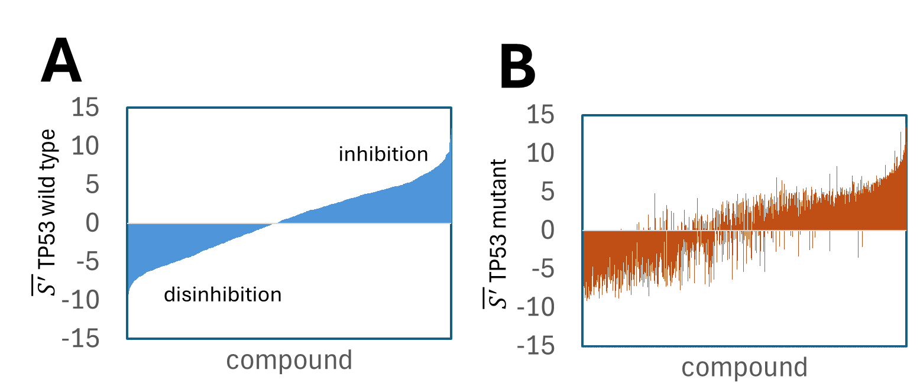
Operationally, compounds with consistently negative (Δ S') values across mutant lines represent strong candidates for further study, as they indicate selective vulnerability of the altered signaling network. Conversely, positive (Δ S') values suggest reduced efficacy or potential adaptive resistance. Because ($\overline{S'}$) accommodates both ascending and descending dose–response curves, it captures paradoxical activation as well as inhibition, preventing misclassification when disinhibition dominates.
Figure 4 highlights compounds with statistically significant differences in ($\overline{S'}$) between TP53-wild-type and TP53-mutant cohorts. TP53-mutant values show a systematic upward shift relative to wild type, and a Mann–Whitney U test confirmed that the two distributions differ significantly (p < 0.05), indicating distinct underlying biological states.

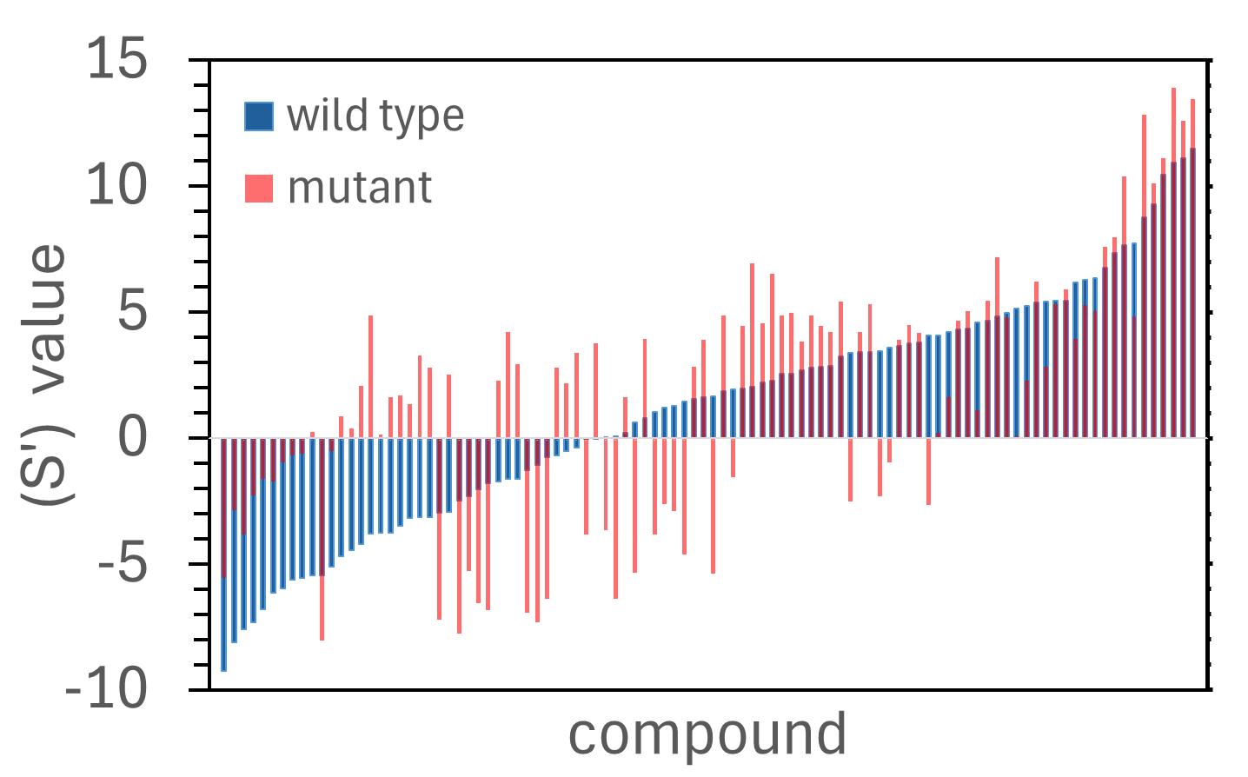
Figure 4. Comparison of $\overline{S'}$values for CNS compounds in TP53-wild-type (blue) and TP53-mutant (red) lines. Compounds are ordered from strongest disinhibition to strongest inhibition based on wild-type $\overline{S'}$. "C:\DESKTOP-EE703MN_D\mocomakers 2024\depmap portal\multiple tumor suppressors\median\CNS_TP53_delta_s_prime.xlsx sheet 8"

Compounds Preferentially Targeting TP53-Mutant Cells
Figure 7 shows compounds selected using thresholds of wild-type ($\overline{S'}$ > -0.5), mutant ($\overline{S'}$ > 2), (ΔS' > 2), and (p < 0.05). All compounds displayed higher S′ values in TP53-mutant cells, with (ΔS') values ranging from –2.0 to –4.9.
Compounds with larger negative values (ΔS' ≤ –4.0)—such as alvocidib (–4.89), docetaxel (–4.26), and SN-38 (–4.08)—show substantially weaker inhibition in wild-type cells. These agents may be effective in TP53-wild-type cancers but risk reduced efficacy or paradoxical activation in mutant-heavy tumors. Conversely, they may serve as strong candidates for synthetic-lethal combinations targeting cell-cycle or DNA-repair vulnerabilities.

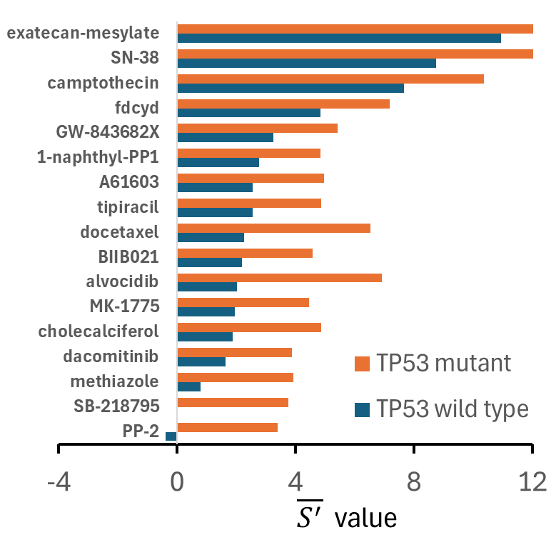
Figure X. Identification of compounds that preferentially target TP53-mutant cells using S′-based criteria. Compounds were filtered using thresholds of ($\overline{S'}$ > -0.5) (wild type), ($\overline{S'}$ > 2) (mutant), (ΔS' > 2), and (p < 0.05). Selected agents span Src inhibitors, DNA-damaging agents, checkpoint inhibitors, and topoisomerase poisons.

Genotype-Agnostic Inhibitors Identified by Dual-Response Screening
To identify compounds capable of suppressing both wild-type and mutant populations—reflecting the heterogeneity of real tumors—we applied stringent dual-response criteria using ($\overline{S'}$). Compounds were required to:
- achieve ($\overline{S'}$ > 5) in both TP53-wild-type and TP53-mutant cohorts,
- fall within a narrow (ΔS') window (0–0.5), and
- show high paired-response concordance ((p >0.8)).
Multiple agents met all criteria (Figure X), indicating a subset of compounds with genotype-agnostic inhibitory activity. ΔS' values were uniformly small (0.006–0.36), and high p-values (0.81–1.0) confirmed that paired responses were statistically indistinguishable.
Mechanistically, aurora kinase inhibitors (barasertib HQPA, alisertib) and microtubule-targeting agents (podophyllotoxin, epothilone A, dolastatin 10) showed strong, consistent inhibition across genotypes. By acting directly on mitotic machinery, these compounds bypass upstream signaling heterogeneity and may retain efficacy in genetically diverse tumors.
Collectively, these results identify a set of compounds whose inhibitory effects are highly conserved between TP53-wild-type and TP53-mutant glioma cells. Their narrow (ΔS') values and high concordance highlight their potential as single-agent therapies capable of overcoming intratumoral diversity—a major barrier in precision oncology.

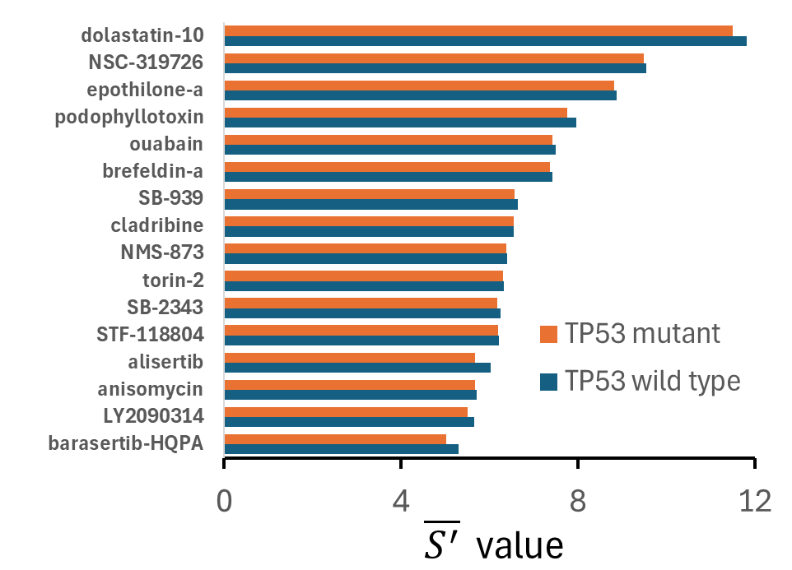
Figure X. Identification of dual-effective compounds using ($\overline{S'}$)-based criteria. Compounds were filtered using ($\overline{S'}$) > 5) in both genotypes, (ΔS' = 0–0.5), and (p > 0.8). Aurora kinase inhibitors and microtubule-targeting agents showed highly similar inhibitory profiles across TP53 backgrounds.

"C:\DESKTOP-EE703MN_D\mocomakers 2024\depmap portal\multiple tumor suppressors\median\CNS_TP53_delta_s_prime.xlsx"

TP53-Dependent Differences Across PI3K, AKT, and mTOR Inhibitors
Table 1 summarizes$\overline{S}$ and ΔS' values for PI3K, AKT, and mTOR inhibitors in CNS cell lines stratified by TP53 mutation status. Across PI3K inhibitors, CNS cell lines displayed highly heterogeneous S′ responses regardless of TP53 status. AKT inhibitors showed a clear trimodal pattern:
- Mutation-sensitive: AZD5363, Uprosertib
- Mutation-resistant: MK-2206, CCT128930
- Broadly active in both genotypes: triciribine, A-674563, GSK2110183
For mTOR inhibitors, several compounds (MLN0128, XL388, sirolimus) showed preferential activity in TP53 wild-type cells.

Table 1. TP53 mutation status modulates pathway dependence differently across PI3K, AKT, and mTOR inhibitors as illustrated using $\overline{S^{'}}$ and ΔS’. Table cells are color-coded to facilitate comparison. $\overline{S}'$ is ranked from most positive (magenta, strong inhibition) to most negative (blue, disinhibition). ΔS' is ranked from most negative (green, mutant-preferential inhibition) to most positive (brown, mutant resistance). "C:\DESKTOP-EE703MN_D\mocomakers 2024\depmap portal\multiple tumor suppressors\median\CNS_TP53_delta_s_prime.xlsx"

Synthetic Lethality in PTEN and TP53 Mutants Across CHK, PARP, and PLK Inhibitors
Synthetic lethality can occur when a mutation creates a selective vulnerability to pathway inhibition [35-37]. Tumor suppressor mutations such as PTEN frequently confer enhanced sensitivity to PARP, CHEK, and PLK inhibitors, consistent with synthetic lethality arising from DNA repair and mitotic checkpoint defects [35,37-39]. Table 2 compares PTEN and TP53 wild-type versus mutant cohorts across CHK, PARP, and PLK inhibitors using $\overline{S}$ and ΔS'. CHK and PLK inhibitors showed strong inhibitory activity in both wild-type and mutant cohorts. PARP inhibitors displayed mixed sensitivity and generally lower S′ values, although niraparib showed enhanced inhibition in PTEN mutants (negative ΔS)'. TP53 mutants showed preferential sensitivity to several PLK inhibitors (GSK461364, GW-843682X, volasertib).

Table 2. Comparison of PTEN wild type vs mutant and TP53 wild type vs mutant responses across three drug classes (CHK inhibitors, PARP inhibitors, PLK inhibitors) as illustrated using $\overline{S^{'}}$ and ΔS’. S’ values are color coded in magenta/blue and ΔS’ in green/brown. The ΔS′ values indicate whether mutants are more inhibited (negative ΔS′) or more resistant (positive ΔS′). "C:\Users\godet\OneDrive\Desktop\computational PPR\cns tp53+pten_PLK-PARP.xlsx"

ΔS′ profiles reveal tissue‑specific synthetic lethal interactions with MEK inhibition.
In breast cancer cell lines, NF1 mutants showed strongly negative ΔS' values for most MEK inhibitors (trametinib –10.9; MEK1/2 inhibitor –8.2; cobimetinib –8.0; AS703026 –7.8), indicating pronounced pathway dependence. A few compounds (PD98059, BIX02188, U0126) showed positive ΔS' highlighting chemotype-specific resistance. In CNS cell lines, responses were mixed, with moderate sensitivity to classical MEK inhibitors (PD98059 –3.8; selumetinib –2.9; cobimetinib –2.1). In lung cancer cell lines, NF1 mutants were predominantly resistant (positive (Δ S'); e.g., trametinib +2.1; selumetinib +6.2; nobiletin +8.3), indicating no synthetic lethality. Large intestine mutants were similarly resistant.

Table 3. Color coded map of ΔS′ sensitivity indices for MEK inhibitors across tissue cohorts with and without NF1 mutations. a color-coded map of S' values across tissues. Rows represent MEK inhibitors; columns represent tissue types. This visualization highlights tissue-specific vulnerabilities: strong sensitivity in breast mutants, moderate sensitivity in CNS, broad resistance in large intestine, and mixed responses in lung. Green: negative ΔS’ (mutant-preferential inhibition); white: near-zero (functionally equivalent); Brown: positive ΔS’ (mutant resistance). "C:\DESKTOP-EE703MN_D\mocomakers 2024\depmap portal\multiple tumor suppressors\NF1.xlsx"

DISCUSSION
Repurposing-oriented high-throughput viability screens [40-42] routinely draw from compound libraries that span the full spectrum of drug development. These libraries typically include FDA-approved oncology and non-oncology drugs, investigational new drugs, natural products, and diverse preclinical small molecules. As a result, they can encompass a pharmacologically heterogeneous collection of agonists, antagonists, modulators, inhibitors, stimulators, anti-inflammatory agents, antibiotics, and other mechanistically distinct compounds. This diversity is intentional: it maximizes the likelihood of uncovering unanticipated vulnerabilities, context-specific activities, and novel therapeutic opportunities across genetically diverse cancer cell lines.
Given this breadth of drug action, cellular responses to pharmacologic perturbation in such screens (and particularly those in cancer screens) are not necessarily expected to conform to a simple monotonic model of inhibition. Instead, viability outcomes in repurposing screens are more likely to span a bidirectional continuum, ranging from profound suppression to neutral effects and, in some cases, overt stimulation. This phenomenon is not merely an artifact of assay noise or off-target toxicity; rather, it reflects the underlying dysregulated architecture of cancer signaling networks [43-45].
This underlying dysregulated architecture in tumor cells results from combinations of oncogene activation, tumor suppressor loss, and the potential of multifaceted pathway rewiring that create complex regulatory landscapes. Within these landscapes, pharmacologic perturbation can trigger [21,30,46,47] feedback loops, compensatory pathway activation, cross-talk between signaling modules, and adaptive rewiring, any of which can invert or amplify the expected direction of drug response.
For example, inhibition of a nominally oncogenic node like KRAS [48] may relieve negative feedback and paradoxically activate upstream or parallel pathways, producing a stimulatory phenotype . Conversely, compounds not traditionally considered cytotoxic—such as metabolic modulators [49] or anti-inflammatory agents [50] —may suppress viability in specific genetic contexts by exploiting latent dependencies. Additionally, epidemiological and experimental evidence indicate that widely used GPCR-targeted drugs may promote or inhibit cancer progression [51,52]. Thus, the bidirectional behavior observed in repurposing screens is a predictable consequence of applying mechanistically diverse perturbations to highly plastic, nonlinear biological systems.
Off-target binding further complicates drug response landscapes. Small-molecule inhibitors typically engage multiple unintended targets, often with lower affinity but potentially high biological impact when off-targets are amplified, mutated, or overexpressed. Receptor tyrosine kinases such as EGFR exemplify this phenomenon: amplification, mutation, or constitutive activation can drive persistent downstream signaling even in the absence of ligand, and inhibition of one node may derepress others. Similar effects occur throughout signaling networks, where downstream components can become hyperactive or rewired, contributing to adaptive resistance and disinhibition.
S′ is well-suited to quantify these effects because it integrates both potency and efficacy while preserving the directionality of the response. In HTS settings, interpreting drug response as a continuum rather than a unidirectional inhibitory effect may be essential in light of the range of compounds tested. It enables the identification of both suppressive and stimulatory phenotypes, clarifies context-specific vulnerabilities, and provides a more accurate representation of how pharmacologic agents interact with the dynamic signaling networks that define cancer cell behavior.
To capture this complexity, we introduce S′—a sign-preserving potency–efficacy index derived from the operational ratio $E_{max} /{EC}_{50}$ —and its cohort-level extension ΔS′. Unlike IC₅₀ or AUC, which quantify only the magnitude of inhibition, S′ is directional: positive values indicate inhibition, whereas negative values reflect disinhibition or paradoxical activation. This directional property makes S′ a robust comparator across compounds, pathways, and genotypes, while ΔS′ highlights mutation- or tissue-specific differences in sensitivity and resistance.
Because S′ quantifies the net functional effect of a compound on a cellular phenotype, traditional mechanistic labels such as partial agonist, full agonist, allosteric activator, allosteric modulator, or competitive inhibitor are not generally meaningful descriptors in the context of S′. These classical terms refer to mechanism-of-action categories at the receptor or enzyme level, describing how a ligand interacts with a specific molecular target. In contrast, S′ is an operational, system-level index that collapses potency and efficacy into a single directional measure of the observed cellular response, regardless of the underlying biochemical mechanism.
S′ is grounded in a modified Black–Leff operational model in which the classical transduction efficacy term is generalized to a net transduction efficacy ($τ_{\text{net}}$). This extension accommodates the full spectrum of inhibitory, neutral, and disinhibitory responses observed in real signaling systems. In this framework, drug binding does not simply “turn down” a pathway; rather, it perturbs a regulatory balance in which inhibition and relief-of-suppression coexist. Depending on pathway topology, feedback strength, and compensatory circuits, the same compound may suppress signaling in one context while triggering rebound activation in another. Such behavior is especially relevant in cancer biology, where dysfunctional signaling and rapid adaptive resistance can shift the balance between inhibition and disinhibition within hours of drug exposure [53]. Accounting for this balance is essential for identifying compounds with durable efficacy.
Across CNS cancer cell lines, S′ values were often bimodal, with substantial fractions of both positive (inhibitory) and negative (disinhibitory) responses. Even within individual cell lines, S′ revealed marked heterogeneity, highlighting the need for metrics that accommodate both descending and ascending concentration–response curves. Compound-level patterns reinforced this interpretive value; for example, cabazitaxel produced uniformly positive S′ values, whereas everolimus and trametinib showed mixed and sometimes negative values consistent with feedback-driven activation in PI3K/mTOR and MAPK pathways [54,55]. Genotype-level analyses further demonstrated how tumor-suppressor loss reshapes drug response, with PTEN-mutant glioma lines showing polarity flips [56] relative to PTEN-wild-type cells and TP53-mutant cohorts displaying broader heterogeneity and synthetic-lethal sensitivities to agents such as Src inhibitors, DNA-damaging drugs, and checkpoint regulators [57,58]. Tissue-specific analyses of NF1-mutant lines likewise revealed strong MEK-inhibitor sensitivity in breast cancer but resistance in large intestine models, with mixed responses in CNS and lung. It should be pointed out that tumors can develop bypass MEK inhibition by activating other pathways, primarily Receptor Tyrosine Kinases (RTKs) and PI3K, creating a feedback loop that reactivates RAS signaling [59].
Collectively, S′ provides a interpretable, direction-preserving ranking index, and ΔS′ enables unitless, systematic ranking across cell-line panels to support comparative pharmacology at scale.

Summary.
The modified Black–Leff model, S′, and ΔS′ provide a unified operational framework for interpreting drug responses in complex biological systems. By incorporating directionality, mechanistic context, and the capacity to detect paradoxical activation, these indices move beyond descriptive metrics and support compound prioritization, mutation-selective targeting, and rational therapeutic design. This framework offers a powerful foundation for precision oncology, drug repurposing, and the identification of synthetic-lethal vulnerabilities across heterogeneous cancer cell populations.

METHODS
High-Throughput Drug Screening Data: Cancer Cell Line Datasets
High throughput drug screening data and cell line mutation data were downloaded from the Cancer Dependency Map (DepMap) portal (https://depmap.org/portal/). Two files were used:
- secondary-screen-dose-response-curve-parameters.csv (SSDRC)
- OmicsSomaticMutationsMatrixDamaging.csv (OSMMD) [60] [61,62].
The SSDRC file is part of the PRISM Repurposing dataset, which reports pooled cell-line viability responses for 1,448 compounds screened against 489 cell lines using an 8-point, 4-fold dilution series beginning at 10 μM [63]. To ensure that the cell lines are authentic and not cross-contaminated with other cell sources, DepMap uses authentication by Short Tandem Repeat (STR) DNA genotyping. Here only cell lines that were verified by STR were used in the analysis. The dataset contains four screens (HTS002, MTS005, MTS006, MTS010) and includes compounds annotated as agonists, antagonists, modulators, inhibitors, stimulators, or undesignated. IC₅₀ values were available for ~52% of compound–cell line pairs.
For this study, we used cancer cell lines described associated with the central nervous system (CNS) as found in HTS002 (483 cell lines, 1,316 compounds) as described by Corsello et al. [63], with updates from MTS010, which contains DepMap “technical redos.” A total of 136 values (~10% of compounds) were replaced with corresponding MTS010 entries, following DepMap’s recommendation to use MTS010 when available. Notably, MTS010 was not included in the original Corsello et al. analysis.
DepMap fits concentration–response curves using a four-parameter log-logistic (4PL) model, providing summary parameters (upper and lower asymptotes, EC₅₀, IC₅₀, Hill slope, AUC). Raw viability data are not included. The upper asymptote is normalized to 1. Both ascending and descending 4PL curves occur, depending on the sign of the slope parameter. AUC values are normalized between 0 and 1, with values >1 indicating increased viability.
The OSMMD file provides a binary matrix indicating whether each cell line carries at least one damaging (likely loss-of-function) mutation in each gene. DepMap assigns a value of 2 when summed allele frequencies exceed 0.95, and 1 otherwise. We focused on tumor suppressor genes, comparing cell lines with two damaging mutations (high likelihood of loss of function) to corresponding wild-type lines. Cell lines with a single damaging mutation were excluded.

Parameter Extraction
Concentration-response curve parameters were from the screens HTS002 and MTS010. The 4PL parameters that were used were:
- (A) = minimum response,
- (D) = maximum response,
- (C) = EC₅₀,
To align 4PL outputs with the operational model:
E_{max} = A - D, EC₅₀ = C
E_{max} was expressed relative to solvent control, and EC₅₀ values were normalized to a 1 μM reference concentration.

Statistical Analysis
Comparisons between wild-type and mutant cohorts were performed using the Mann–Whitney U test, requiring ≥3 cell lines per group. Significance was defined as p < 0.05.

Pathway and Genotype Annotation
Mechanism of action assignments (PI3K, AKT, mTOR, MEK, CHK, PARP, PLK) were used as provided in the DepMap files. Pathway assignments (e.g. PI3K-AKT- mTOR) were based on curated databases and literature. Genotype annotations for PTEN, TP53, and NF1 were obtained from DepMap.

Visualization
Histograms, dot-density maps, and heatmaps were generated to visualize:
- S′ distributions
- Cohort-level distributions, $\overline{S'}$
- ΔS′ genotype-specific differences
- Tissue-specific synthetic-lethal patterns
Color scales were standardized across figures to distinguish inhibition (magenta/brown) from disinhibition (blue/green).

Thresholds
Compound responses were classified into inhibitory, neutral, or disinhibitory categories using thresholds of:
- Inhibition: (S’ >+2)
- Neutral: (S' between -2 and +2)
- Disinhibition: (S' < -2)
We defined S′ ≥ 2 (and similarly S’ < -2) as a threshold for biologically meaningful responses. This choice is grounded in the geometry of the asinh transform and the empirical distribution of S′ based on histogram analysis. Because asinh transitions from linear to logarithmic behavior at x ≈ 1, values with S′ < 1 lie in a near linear, noise dominated regime around neutrality (S′ = 0). In contrast, S′ = 2 corresponds to an underlying potency–efficacy ratio of approximately 3.6 (back-converted with sinh), placing it well within the nonlinear, log-like regime where effects are clearly distinguishable from small fluctuations. S′ ≥ 2 (and S’< -2) identifies responses with moderate or stronger net inhibition (or disinhibition), consistent with a biologically meaningful shift in pathway output.
These thresholds were applied uniformly to S′, $\overline{S'}$, and ΔS′ to ensure consistent classification of inhibition, disinhibition, and mutation-dependent divergence.

REFERENCES
1. Castoreno, A.B.; Eggert, U.S. Small molecule probes of cellular pathways and networks. ACS Chem Biol 2011, 6, 86–94, doi:10.1021/cb1002976.
2. Farquhar, K.S.; Charlebois, D.A.; Szenk, M.; Cohen, J.; Nevozhay, D.; Balázsi, G. Role of network-mediated stochasticity in mammalian drug resistance. Nature Communications 2019, 10, 2766, doi:10.1038/s41467-019-10330-w.
3. Kholodenko, B.N.; Rauch, N.; Kolch, W.; Rukhlenko, O.S. A systematic analysis of signaling reactivation and drug resistance. Cell Rep 2021, 35, 109157, doi:10.1016/j.celrep.2021.109157.
4. Silverman, E.K.; Schmidt, H.; Anastasiadou, E.; Altucci, L.; Angelini, M.; Badimon, L.; Balligand, J.L.; Benincasa, G.; Capasso, G.; Conte, F.; et al. Molecular networks in Network Medicine: Development and applications. Wiley Interdiscip Rev Syst Biol Med 2020, 12, e1489, doi:10.1002/wsbm.1489.
5. Barabási, A.L.; Gulbahce, N.; Loscalzo, J. Network medicine: a network-based approach to human disease. Nature reviews. Genetics 2011, 12, 56–68, doi:10.1038/nrg2918.
6. Hopkins, A.L. Network pharmacology: the next paradigm in drug discovery. Nat Chem Biol 2008, 4, 682–690, doi:10.1038/nchembio.118.
7. Zhao, S.; Iyengar, R. Systems pharmacology: network analysis to identify multiscale mechanisms of drug action. Annu Rev Pharmacol Toxicol 2012, 52, 505–521, doi:10.1146/annurev-pharmtox-010611-134520.
8. Kim, D.W.; Hong, H.; Kim, J.K. Systematic inference identifies a major source of heterogeneity in cell signaling dynamics: The rate-limiting step number. Sci Adv 2022, 8, eabl4598, doi:10.1126/sciadv.abl4598.
9. Krämer, N.; van Eijl, R.; Stohn, T.; Tanis, S.; Wessels, L.; Bosdriesz, E.; Mulder, K.W. Cell-state specific drug-responses are associated with differences in signaling network wiring. bioRxiv 2025, 2025.2001.2027.635060, doi:10.1101/2025.01.27.635060.
10. Finak, G.; Gottardo, R. Promises and Pitfalls of High-Throughput Biological Assays. Methods Mol Biol 2016, 1415, 225–243, doi:10.1007/978-1-4939-3572-7_12.
11. Mennen, S.M.; Alhambra, C.; Allen, C.L.; Barberis, M.; Berritt, S.; Brandt, T.A.; Campbell, A.D.; Castañón, J.; Cherney, A.H.; Christensen, M.; et al. The Evolution of High-Throughput Experimentation in Pharmaceutical Development and Perspectives on the Future. Organic Process Research & Development 2019, 23, 1213–1242, doi:10.1021/acs.oprd.9b00140.
12. Eglen, R.M.; Reisine, T. GPCRs Revisited: New Insights Lead to Novel Drugs. Pharmaceuticals (Basel) 2011, 4, 244–272, doi:10.3390/ph4020244.
13. Bleach, R.; McIlroy, M. The Divergent Function of Androgen Receptor in Breast Cancer; Analysis of Steroid Mediators and Tumor Intracrinology. Front Endocrinol (Lausanne) 2018, 9, 594, doi:10.3389/fendo.2018.00594.
14. Heldring, N.; Pike, A.; Andersson, S.; Matthews, J.; Cheng, G.; Hartman, J.; Tujague, M.; Ström, A.; Treuter, E.; Warner, M.; et al. Estrogen Receptors: How Do They Signal and What Are Their Targets. Physiological Reviews 2007, 87, 905–931, doi:10.1152/physrev.00026.2006.
15. Fox, E.M.; Andrade, J.; Shupnik, M.A. Novel actions of estrogen to promote proliferation: integration of cytoplasmic and nuclear pathways. Steroids 2009, 74, 622–627, doi:10.1016/j.steroids.2008.10.014.
16. Sinha, S.; Sinha, N.; Perales, M.; Tarrab, A.; Nguyen, T.; Liu, L.; Cantore, T.; Alvarez, K.; Patiyal, S.; Mukherjee, S.; et al. DeepTarget predicts anti-cancer mechanisms of action of small molecules by integrating drug and genetic screens. npj Precision Oncology 2025, 9, 340, doi:10.1038/s41698-025-01111-4.
17. Higuchi, M.; Ishiyama, K.; Maruoka, M.; Kanamori, R.; Takaori-Kondo, A.; Watanabe, N. Paradoxical activation of c-Src as a drug-resistant mechanism. Cell Reports 2021, 34, doi:10.1016/j.celrep.2021.108876.
18. Kim, L.M.; Kim, P.Y.; Gebreyohannes, Y.K.; Leung, C.T. Sustained Oncogenic Signaling in the Cytostatic State Enables Targeting of Nonproliferating Persistent Cancer Cells. Cancer Res 2022, 82, 3045–3057, doi:10.1158/0008-5472.Can-21-2908.
19. Kim, P.Y.; Leung, C.T. Therapeutic potentials and challenges of cytostatic persister cancer cells. Oncotarget 2023, 14, 944–945, doi:10.18632/oncotarget.28488.
20. Tuomela, K.; Ambrose, A.R.; Davis, D.M. Escaping Death: How Cancer Cells and Infected Cells Resist Cell-Mediated Cytotoxicity. Front Immunol 2022, 13, 867098, doi:10.3389/fimmu.2022.867098.
21. Tyner, J.W.; Haderk, F.; Kumaraswamy, A.; Baughn, L.B.; Van Ness, B.; Liu, S.; Marathe, H.; Alumkal, J.J.; Bivona, T.G.; Chan, K.S.; et al. Understanding Drug Sensitivity and Tackling Resistance in Cancer. Cancer Res 2022, 82, 1448–1460, doi:10.1158/0008-5472.CAN-21-3695.
22. Barouch-Bentov, R.; Sauer, K. Mechanisms of drug resistance in kinases. Expert Opin Investig Drugs 2011, 20, 153–208, doi:10.1517/13543784.2011.546344.
23. Black, J.W.; Leff, P. Operational models of pharmacological agonism. Proc R Soc Lond B Biol Sci 1983, 220, 141–162, doi:10.1098/rspb.1983.0093.
24. Wodak, S.J.; Paci, E.; Dokholyan, N.V.; Berezovsky, I.N.; Horovitz, A.; Li, J.; Hilser, V.J.; Bahar, I.; Karanicolas, J.; Stock, G.; et al. Allostery in Its Many Disguises: From Theory to Applications. Structure 2019, 27, 566–578, doi:10.1016/j.str.2019.01.003.
25. Kenakin, T. The Quantitative Characterization of Functional Allosteric Effects. Curr Protoc Pharmacol 2017, 76, 9.22.21–29.22.10, doi:10.1002/cpph.18.
26. Nussinov, R.; Tsai, C.J.; Liu, J. Principles of allosteric interactions in cell signaling. Journal of the American Chemical Society 2014, 136, 17692–17701, doi:10.1021/ja510028c.
27. Mathy, C.J.P.; Kortemme, T. Emerging maps of allosteric regulation in cellular networks. Curr Opin Struct Biol 2023, 80, 102602, doi:10.1016/j.sbi.2023.102602.
28. Doppel, F.A.a.V., M. Efficient neural network models of chemical kinetics using a latent asinh rate transformation. React. Chem. Eng 2023, 8, 2620 – 2631, doi:DOI: 10.1039/d3re00212h.
29. Kurahashi, I.; Fujita, Y.; Arao, T.; Kurata, T.; Koh, Y.; Sakai, K.; Matsumoto, K.; Tanioka, M.; Takeda, K.; Takiguchi, Y.; et al. A microarray-based gene expression analysis to identify diagnostic biomarkers for unknown primary cancer. PLoS One 2013, 8, e63249, doi:10.1371/journal.pone.0063249.
30. Trusolino, L.; Bertotti, A. Compensatory Pathways in Oncogenic Kinase Signaling and Resistance to Targeted Therapies: Six Degrees of Separation. Cancer Discovery 2012, 2, 876–880, doi:10.1158/2159-8290.Cd-12-0400.
31. Khan, S.U.; Fatima, K.; Aisha, S.; Malik, F. Unveiling the mechanisms and challenges of cancer drug resistance. Cell Communication and Signaling 2024, 22, 109, doi:10.1186/s12964-023-01302-1.
32. Kenakin, T.; Watson, C.; Muniz-Medina, V.; Christopoulos, A.; Novick, S. A simple method for quantifying functional selectivity and agonist bias. ACS Chem Neurosci 2012, 3, 193–203, doi:10.1021/cn200111m.
33. He, K.; Chen, D.; Ruan, H.; Li, X.; Tong, J.; Xu, X.; Zhang, L.; Yu, J. BRAFV600E-dependent Mcl-1 stabilization leads to everolimus resistance in colon cancer cells. Oncotarget 2016, 7, 47699–47710, doi:10.18632/oncotarget.10277.
34. Pournajaf, S.; Pourgholami, M.H. The mTOR pathway in Gliomas: From molecular insights to targeted therapies. Biomed Pharmacother 2025, 189, 118237, doi:10.1016/j.biopha.2025.118237.
35. Setton, J.; Zinda, M.; Riaz, N.; Durocher, D.; Zimmermann, M.; Koehler, M.; Reis-Filho, J.S.; Powell, S.N. Synthetic Lethality in Cancer Therapeutics: The Next Generation. Cancer Discov 2021, 11, 1626–1635, doi:10.1158/2159-8290.cd-20-1503.
36. Liu, Y.; Hu, X.; Han, C.; Wang, L.; Zhang, X.; He, X.; Lu, X. Targeting tumor suppressor genes for cancer therapy. BioEssays : news and reviews in molecular, cellular and developmental biology 2015, 37, 1277–1286, doi:10.1002/bies.201500093.
37. Lord, C.J.; Ashworth, A. PARP inhibitors: Synthetic lethality in the clinic. Science 2017, 355, 1152–1158, doi:10.1126/science.aam7344.
38. Maugeri-Sacca, M.; Bartucci, M.; De Maria, R. Checkpoint kinase 1 inhibitors for potentiating systemic anticancer therapy. Cancer Treat Rev 2013, 39, 525–533, doi:10.1016/j.ctrv.2012.10.007.
39. Vermeulen, M.; Craig, A.W.; Babak, T. Challenges and opportunities for drug repurposing in cancers based on synthetic lethality induced by tumor suppressor gene mutations. bioRxiv 2025, 2025.2003.2020.644275, doi:10.1101/2025.03.20.644275.
40. Corsello, S.M.; Nagari, R.T.; Spangler, R.D.; Rossen, J.; Kocak, M.; Bryan, J.G.; Humeidi, R.; Peck, D.; Wu, X.; Tang, A.A.; et al. Discovering the anti-cancer potential of non-oncology drugs by systematic viability profiling. Nat Cancer 2020, 1, 235–248, doi:10.1038/s43018-019-0018-6.
41. Ferrer, M.; Gosline, S.J.C.; Stathis, M.; Zhang, X.; Guo, X.; Guha, R.; Ryman, D.A.; Wallace, M.R.; Kasch-Semenza, L.; Hao, H.; et al. Pharmacological and genomic profiling of neurofibromatosis type 1 plexiform neurofibroma-derived schwann cells. Sci Data 2018, 5, 180106, doi:10.1038/sdata.2018.106.
42. Inglese, J.; Auld, D.S.; Jadhav, A.; Johnson, R.L.; Simeonov, A.; Yasgar, A.; Zheng, W.; Austin, C.P. Quantitative high-throughput screening: a titration-based approach that efficiently identifies biological activities in large chemical libraries. Proc Natl Acad Sci U S A 2006, 103, 11473–11478, doi:10.1073/pnas.0604348103.
43. Ryspayeva, D.; Seyhan, A.A.; MacDonald, W.J.; Purcell, C.; Roady, T.J.; Ghandali, M.; Verovkina, N.; El-Deiry, W.S.; Taylor, M.S.; Graff, S.L. Signaling pathway dysregulation in breast cancer. Oncotarget 2025, 16, 168–201, doi:10.18632/oncotarget.28701.
44. Bou Antoun, N.; Chioni, A.M. Dysregulated Signalling Pathways Driving Anticancer Drug Resistance. Int J Mol Sci 2023, 24, doi:10.3390/ijms241512222.
45. Wan, M.; Zhuang, C.; Li, W.; Yan, R.; Chen, W.; Cheng, J.; Yue, C.; Chen, L.; Quan, Y. Mutational accumulation drives pathway dysregulation to predict glioma patient survival. Scientific Reports 2025, 15, 26656, doi:10.1038/s41598-025-12346-3.
46. Wang, X.; Zhang, H.; Chen, X. Drug resistance and combating drug resistance in cancer. Cancer Drug Resist 2019, 2, 141–160, doi:10.20517/cdr.2019.10.
47. Soragni, A.; Knudsen, E.S.; O'Connor, T.N.; Tognon, C.E.; Tyner, J.W.; Gini, B.; Kim, D.; Bivona, T.G.; Zang, X.; Witkiewicz, A.K.; et al. Acquired resistance in cancer: towards targeted therapeutic strategies. Nature reviews. Cancer 2025, 25, 613–633, doi:10.1038/s41568-025-00824-9.
48. Ash, L.J.; Busia-Bourdain, O.; Okpattah, D.; Kamel, A.; Liberchuk, A.; Wolfe, A.L. KRAS: Biology, Inhibition, and Mechanisms of Inhibitor Resistance. Curr Oncol 2024, 31, 2024–2046, doi:10.3390/curroncol31040150.
49. Abildgaard, C.; Rizza, S.; Christiansen, H.; Schmidt, S.; Dahl, C.; Abdul-Al, A.; Christensen, A.; Filomeni, G.; Guldberg, P. Screening of metabolic modulators identifies new strategies to target metabolic reprogramming in melanoma. Scientific Reports 2021, 11, 4390, doi:10.1038/s41598-021-83796-8.
50. Zappavigna, S.; Cossu, A.M.; Grimaldi, A.; Bocchetti, M.; Ferraro, G.A.; Nicoletti, G.F.; Filosa, R.; Caraglia, M. Anti-Inflammatory Drugs as Anticancer Agents. Int J Mol Sci 2020, 21, doi:10.3390/ijms21072605.
51. Arang, N.; Gutkind, J.S. G Protein-Coupled receptors and heterotrimeric G proteins as cancer drivers. FEBS Lett 2020, 594, 4201–4232, doi:10.1002/1873-3468.14017.
52. Cornwell, A.C.; Feigin, M.E. Unintended Effects of GPCR-Targeted Drugs on the Cancer Phenotype. Trends Pharmacol Sci 2020, 41, 1006–1022, doi:10.1016/j.tips.2020.10.001.
53. Ryan, M.B.; Fece de la Cruz, F.; Phat, S.; Myers, D.T.; Wong, E.; Shahzade, H.A.; Hong, C.B.; Corcoran, R.B. Vertical Pathway Inhibition Overcomes Adaptive Feedback Resistance to KRAS(G12C) Inhibition. Clin Cancer Res 2020, 26, 1633–1643, doi:10.1158/1078-0432.Ccr-19-3523.
54. Rozengurt, E.; Soares, H.P.; Sinnet-Smith, J. Suppression of feedback loops mediated by PI3K/mTOR induces multiple overactivation of compensatory pathways: an unintended consequence leading to drug resistance. Mol Cancer Ther 2014, 13, 2477–2488, doi:10.1158/1535-7163.Mct-14-0330.
55. Carracedo, A.; Ma, L.; Teruya-Feldstein, J.; Rojo, F.; Salmena, L.; Alimonti, A.; Egia, A.; Sasaki, A.T.; Thomas, G.; Kozma, S.C.; et al. Inhibition of mTORC1 leads to MAPK pathway activation through a PI3K-dependent feedback loop in human cancer. The Journal of Clinical Investigation 2008, 118, 3065–3074, doi:10.1172/JCI34739.
56. Hashemi, M.; Etemad, S.; Rezaei, S.; Ziaolhagh, S.; Rajabi, R.; Rahmanian, P.; Abdi, S.; Koohpar, Z.K.; Rafiei, R.; Raei, B.; et al. Progress in targeting PTEN/PI3K/Akt axis in glioblastoma therapy: Revisiting molecular interactions. Biomedicine & Pharmacotherapy 2023, 158, 114204, doi:https://doi.org/10.1016/j.biopha.2022.114204.
57. McCubrey, J.A.; Follo, M.Y.; Ratti, S.; Martelli, A.M.; Manzoli, L.; Augello, G.; Cervello, M.; Cocco, L. TP53 gene status can promote sensitivity and resistance to chemotherapeutic drugs and small molecule signal transduction inhibitors. Adv Biol Regul 2025, 95, 101073, doi:10.1016/j.jbior.2024.101073.
58. Shim, Y.J. Therapeutic Targeting of DNA Damage Response Pathways in TP53- and ATM-Mutated Tumors. Brain Tumor Res Treat 2025, 13, 73–80, doi:10.14791/btrt.2025.0017.
59. Chen, C.H.; Hsia, T.C.; Yeh, M.H.; Chen, T.W.; Chen, Y.J.; Chen, J.T.; Wei, Y.L.; Tu, C.Y.; Huang, W.C. MEK inhibitors induce Akt activation and drug resistance by suppressing negative feedback ERK-mediated HER2 phosphorylation at Thr701. Mol Oncol 2017, 11, 1273–1287, doi:10.1002/1878-0261.12102.
60. DepMap, B. Current DepMap Release data, including CRISPR Screens, PRISM Drug Screens, Copy Number, Mutation, Expression, and Fusions. DepMap 23Q4 Public. Figshare+. Dataset. https://doi.org/10.25452/figshare.plus.24667905.v2 2023.
61. Picco, G.; Chen, E.D.; Alonso, L.G.; Behan, F.M.; Gonçalves, E.; Bignell, G.; Matchan, A.; Fu, B.; Banerjee, R.; Anderson, E.; et al. Functional linkage of gene fusions to cancer cell fitness assessed by pharmacological and CRISPR-Cas9 screening. Nature Communications 2019, 10, 2198, doi:10.1038/s41467-019-09940-1.
62. Iorio, F.; Knijnenburg, T.A.; Vis, D.J.; Bignell, G.R.; Menden, M.P.; Schubert, M.; Aben, N.; Gonçalves, E.; Barthorpe, S.; Lightfoot, H.; et al. A Landscape of Pharmacogenomic Interactions in Cancer. Cell 2016, 166, 740–754, doi:10.1016/j.cell.2016.06.017.
63. Corsello, S.M.; Nagari, R.T.; Spangler, R.D.; Rossen, J.; Kocak, M.; Bryan, J.G.; Humeidi, R.; Peck, D.; Wu, X.; Tang, A.A.; et al. Discovering the anticancer potential of non-oncology drugs by systematic viability profiling. Nature Cancer 2020, 1, 235–248, doi:10.1038/s43018-019-0018-6.

